1. Dsa.msc
2. View->check Advanced Features, which will give out more features
3. Navigate to \PHSA\Service Accounts OU, which is for PHSA service accounts. Using find menu to find the OU in other HAs.
4. Right click on Service Accounts OU and select New=>user
5. 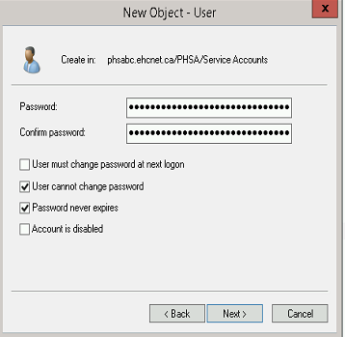
6. 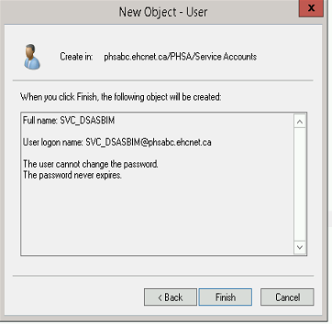
7. Right click on the created service account => select property to add the description